1. Design TM using simulator to perform subtraction of aaa-aa

INPUT:

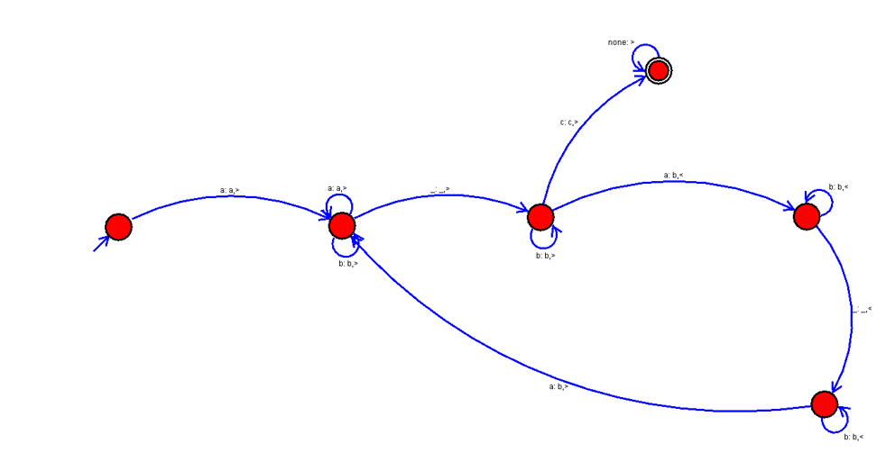

OUTPUT:

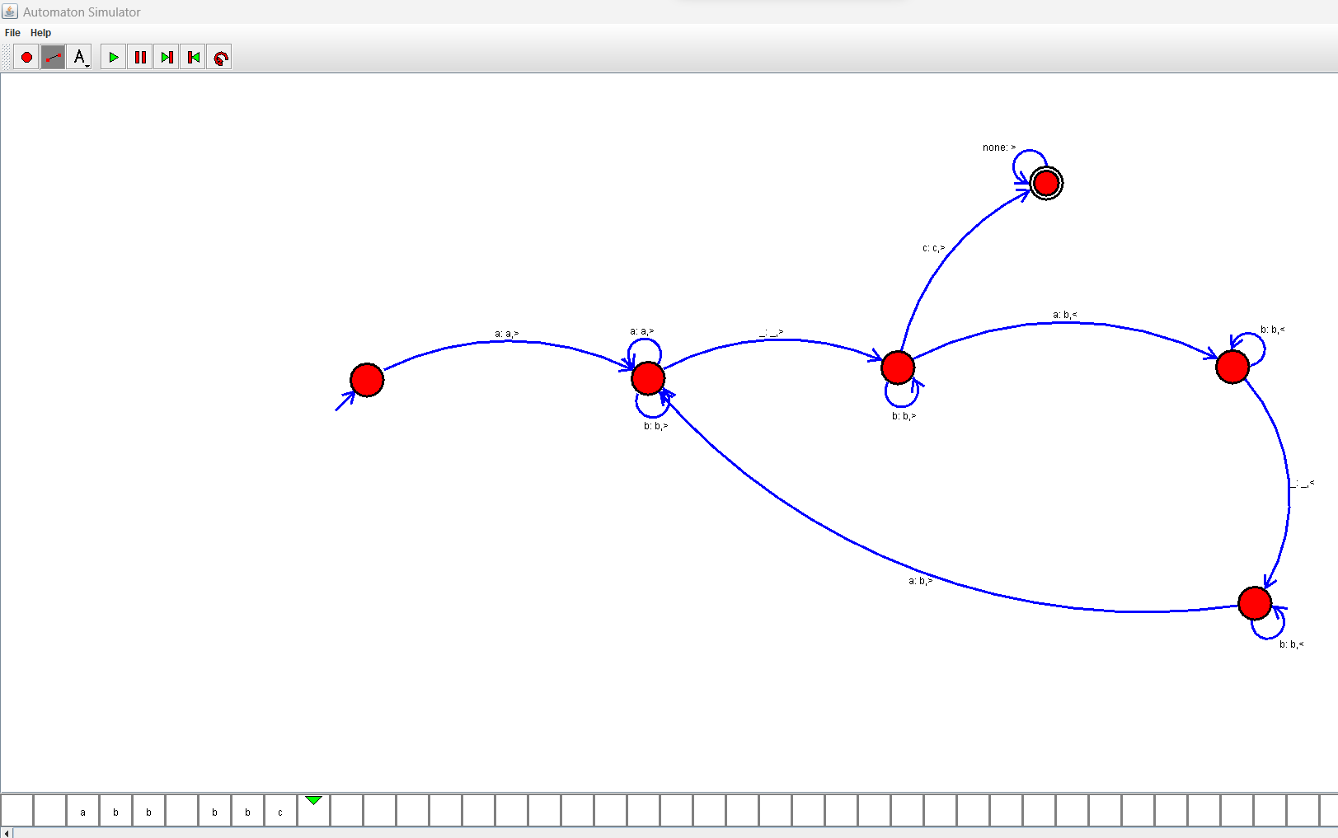

RESULTS:

We designed TM using simulator to perform subtraction of aaa-aa by using autosim